Data Types
- Structured - Data that can be represented using tables with very strict schema. Each row must follow defined schema. Some tables have defined relationships between them. Typically used in relational databases.
- Semi-structured - Data that can be represented using tables but without strict defined schema. Rows must only have unique key identifier.
- Unstructured - Any files in any format. Like binary files, application files, images, movies, etc.

Blob Storage
- BLOB – binary large object – file ; BLOB = file
- Designed for storage of files of any kind
- Three storage tiers
  - Hot – frequently accessed data
  - Cool – infrequently accessed data (lower availability, high durability)
  - Archive – rarely (if-ever) accessed data
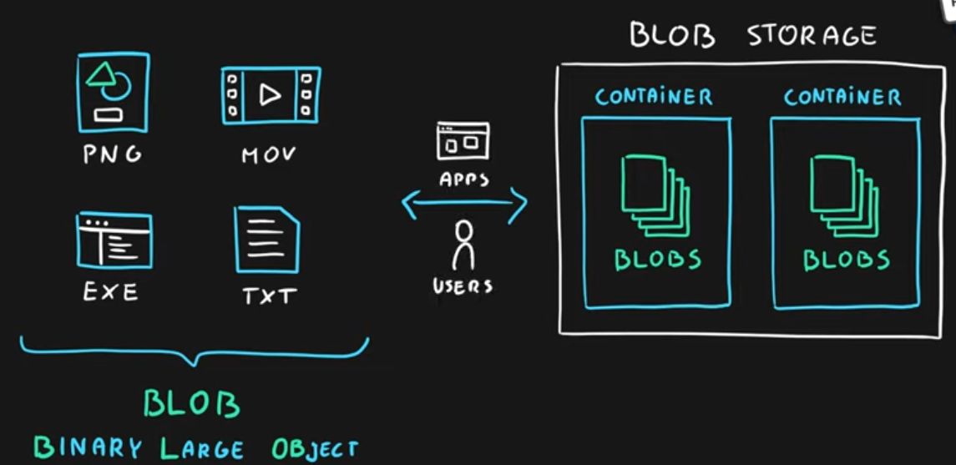

Queue Storage
- Storage for small pieces of data (messages)
- Designed for scalable asynchronous processing
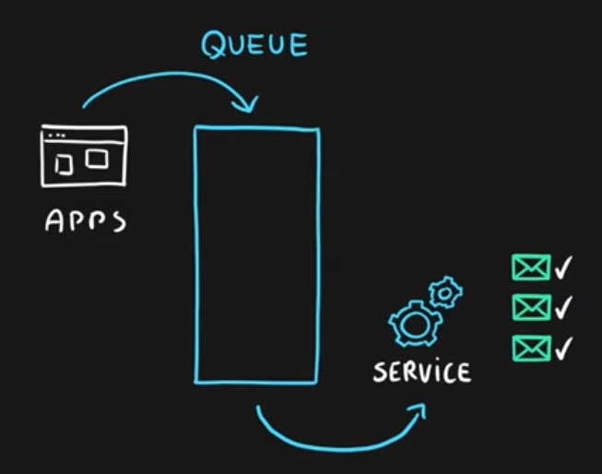

Table Storage
- Storage for semi-structured data (NoSQL)
  - No need for foreign joins, foreign keys, relationships or strict schema
  - Designed for fast access
- Many programming interfaces and SDKs

File Storage
- Storage for files accessed via shared drive protocols
- Designed to extend on-premise file shares or implement lift-and-shift scenarios

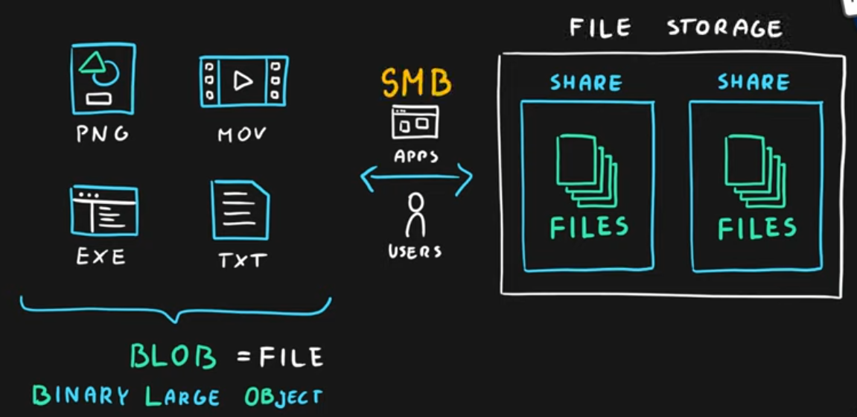
The difference between File storage and Blob storage is that the file storage can be accessed via SMB Protocol:
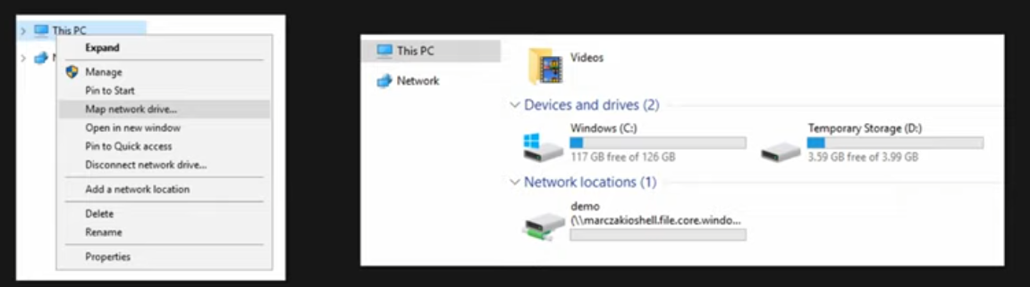

Storage Account
- Group of services which include
  - blob storage,
  - queue storage,
  - table storage, and
  - file storage
- Used to store
  - files,
  - messages, and
  - semi-structured data
- Highly scalable (up to petabytes of data)
- Highly durable (99.999999999% - 11 nines, up to 16 nines)
- Cheapest per GB storage
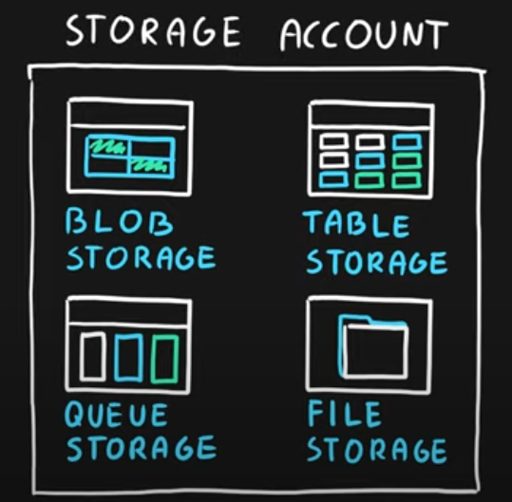

Disk Storage
- Disk emulation in the cloud
- Persistent storage for Virtual Machines
- Different
  - sizes,
  - types (SSD, HDD)
  - performance tiers
- Disk can be unmanaged or managed
